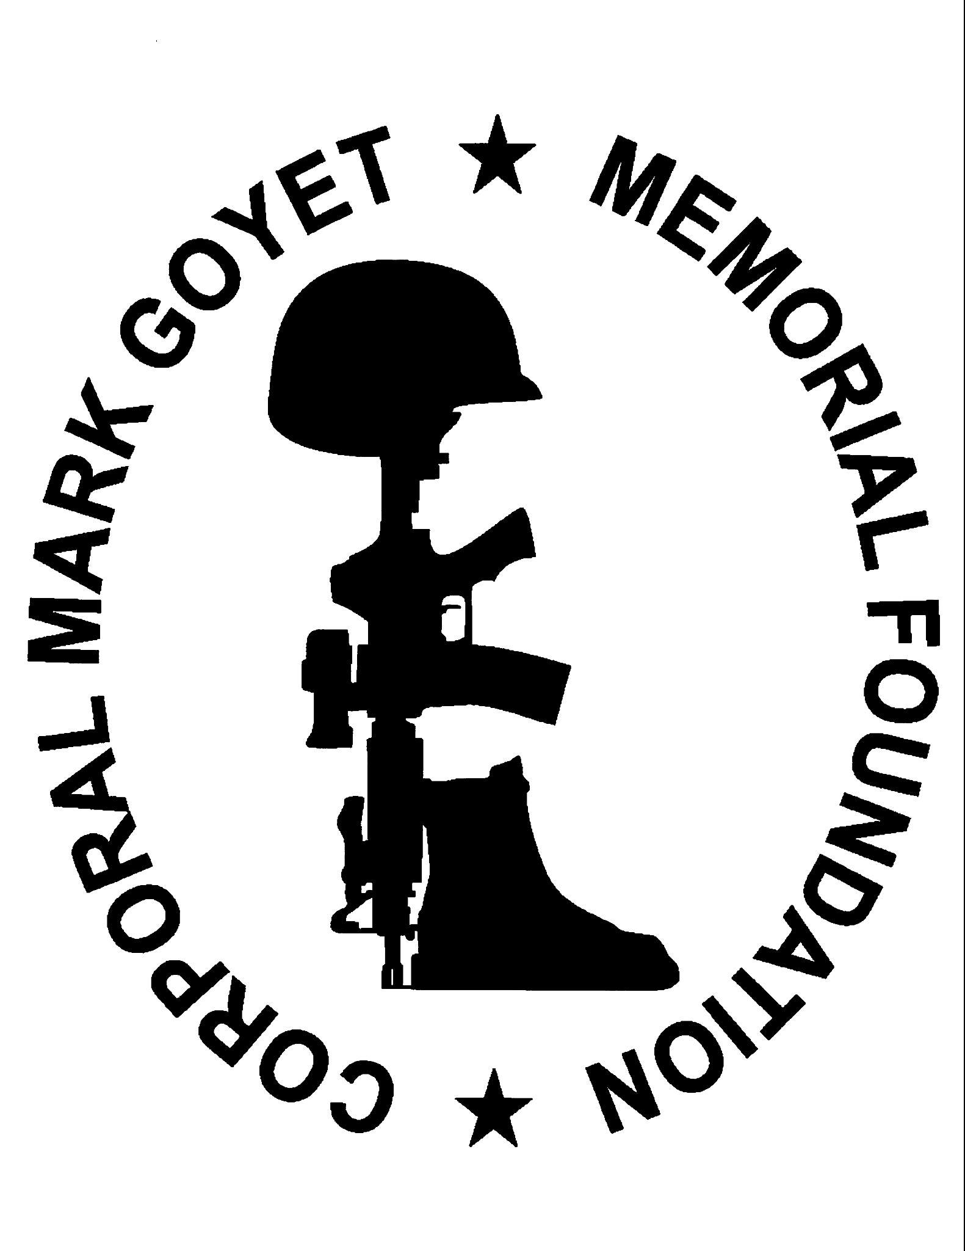
The 2026 Corporal Mark Goyet Memorial Foundation, Inc. Scholarship

QUALIFICATIONS:
• Minimum GPA: 3.0 on a 4.0 scale
• Eligibility: 2026 graduating High School senior

REQUIRED DOCUMENTS:
• Official Transcript
• Essay (500 words, type-written, double-spaced)

OPTIONAL DOCUMENTS:
• Letters of Recommendation (Faculty, Coaches, Board Members, etc.)

MAIL APPLICATIONS TO:
The Corporal Mark Goyet Memorial Foundation, Inc.
P.O. Box 6486
Virginia Beach, VA 23456
NOTE: Applications must be postmarked no later than February 27, 2026.

PERSONAL INFORMATION:
Name of Applicant:
Date of Birth:
Home Address:
Phone:
Father’s Name:
Mother’s Name:

ACADEMIC INFORMATION:
Class Rank:
Current GPA:
ACT or SAT Scores:
Extra-curricular Activities:
Volunteer Work:
List the names of the institutions where you have applied:
List the names of the institutions where you have been accepted:

GOALS:
Briefly describe your short-term goals (next year):
Briefly describe your long-term goals (3–5 years):

ESSAY REQUIREMENT:
As part of your application, you are required to interview a veteran of the armed services and write a 500-word essay capturing what service meant to the veteran, when and where they served, and what they would like remembered about their service. The applicant must also share their own thoughts on service in the armed forces and what it means for our nation.

